Comparison of changes in product technical requirements
This document is provided by the applicant or the registrant

Before change:
1.1 Specification/model
Annex A
Model | Description | Instructions for use | Delivery status | Material of body-contact part | Dimension
0040-10 | Suction Coagulator, Foot control, 6" cannula, 10ft cord, 10 French | Disposable | Sterile | 300 stainless steel | 15.2 cm
0040-25 | Suction Coagulator, Foot control, 6" cannula, 10ft cord, 10 French | Disposable | Sterile | 300 stainless steel | 15.2 cm
0041-25 | Suction Coagulator, Hand control, 6" cannula, 10ft cord, 10 French | Disposable | Sterile | 300 stainless steel | 15.2 cm
0042-25 | Suction Coagulator, Hand control, 6" cannula, 10ft cord, 8 French | Disposable | Sterile | 300 stainless steel | 15.2 cm
0043-25 | Suction Coagulator, Hand control, 6" cannula, 10ft cord, 12 French | Disposable | Sterile | 300 stainless steel | 15.2 cm

After change:
Model | Description | Instructions for use | Delivery status | Material of body-contact part | Dimension
004010J | Suction Coagulator, Foot control, 6" cannula, 10ft cord, 10 French | Disposable | Sterile | 300 stainless steel | 15.2 cm
004025 | Suction Coagulator, Foot control, 6" cannula, 10ft cord, 10 French | Disposable | Sterile | 300 stainless steel | 15.2 cm
004125 | Suction Coagulator, Hand control, 6" cannula, 10ft cord, 10 French | Disposable | Sterile | 300 stainless steel | 15.2 cm
004225 | Suction Coagulator, Hand control, 6" cannula, 10ft cord, 8 French | Disposable | Sterile | 300 stainless steel | 15.2 cm
004325 | Suction Coagulator, Hand control, 6" cannula, 10ft cord, 12 French | Disposable | Sterile | 300 stainless steel | 15.2 cm

No. of Product Technical Requirements for Medical Device
This document is provided by the applicant or the registrant
Megadyne electrosurgical pencil
- Model/specification
  - Specification/model: See Annex A.
  - Structural diagram: See Figure 1 and Figure 2.
  - The electrosurgical pencil and connecting cord are provided in the sterilized package. The sterilization method is Gamma ray sterilization, and the shelf life of sterilization is 5 years.
  - Product diagram: See Annex B.
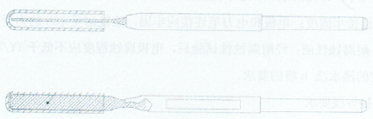
Figure 1: Structural diagram of electrode
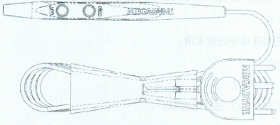
Figure 2: Structural diagram of electrosurgical pencil shaft and connecting cord
- Performance indicators
  - Appearance: The external surface of electrosurgical pencil shall be clean and free of spots and rough surface causing damage.
  - Dimension: The length of electrosurgical pencil handle is 155 mm, with the tolerance of ±10%.
  - Connection firmness: The connection between the electrosurgical pencil and connectors shall withstand a force of 40 N without fracture.
  - Fitting performance: The electrosurgical pencil shall be free of looseness and the combined accessories shall have good service performance.
  - Switch (Model 0043-25 only has the blue switch): The switch of the electrosurgical pencil near the electrode is for electrocision, and the distal end is for electrocoagulation; the color code of electrocision is yellow, and that for electrocoagulation is blue.
  - Requirements for electrode
    - Appearance: The product surface shall have no such defects as rust or scar.
    - Dimension: See Annex A for details, with the tolerance of ±10%.
    - Connection firmness: The connection between the electrode and the electrosurgical pencil should be firm and able to withstand a force of 15 N without looseness.
    - Corrosion resistance: After the corrosion resistance test, the corrosion of the electrode should at least meet the requirements of Grade b of the boiling water method specified in YY/T 0149-2006.
  - Requirements for connecting cord
    - Appearance: The external surface of connecting cord shall be clean and free from processing defects.
    - Dimension: The length of connecting cord is 3000 mm, with the tolerance of ±10%.
    - Connection firmness: The connection between the connecting cord and connectors shall withstand a force of 40 N without fracture.
    - Fitting performance: The connecting cord is used together with the machine and has good fitting performance.
  - Sterility requirements
The electrosurgical pencil and the connecting cord shall be sterile.
  - Electrical safety
    - Safety characteristics of product
Intensity of protection against electric shock: Type CF applied part.
    - Requirements
The requirements of GB 9706.1-2007 and GB 9706.4-2009 shall apply.
  - Requirements for flow rate
The suction flow rate shall not be lower than 500 mL/min.
  - Electromagnetic compatibility: It shall comply with the requirements of YY 0505-2012 and Clause 36 of GB 9706.4-2009.
- Test methods
  - Appearance: Verification can be checked through visual inspection.
  - Dimensions: Use a standard or special measuring tool to make measurement.
  - Connection firmness: Apply a force of 40 N between the electrosurgical pencil and the connector for 15 s; the result shall comply with the requirements of 2.3.
  - Fitting performance: Verification shall be checked by operation of the product.
  - Switch: Verification can be checked through inspection.
  - Electrode test
    - Appearance: Verification can be checked through visual inspection.
    - Dimensions: Use a standard or special measuring tool to make measurement.
    - Connection firmness: Apply a force of 15 N between the electrode and the electrosurgical pencil for 15 s; the result shall comply with the requirements of 2.6.3.
    - Corrosion resistance: Conduct the test according to the boiling water method specified in YY/T 0149-2006; the result shall comply with the requirements of 2.6.4.
    - Test for outer diameter: Use a standard or special measuring tool to make measurement; the result shall comply with the requirements.
  - Test for connecting cord
    - Appearance: Verification can be checked through visual inspection.
    - Dimensions: Use a standard or special measuring tool to make measurement.
    - Connection firmness: Apply a force of 40 N between the connecting cord and connectors for 15 s; the result shall comply with the requirements of 2.7.3.
    - Fitting performance: Verification shall be checked by operation of the product.
  - Sterility test
Conduct the test according to the sterility test method specified in General "1101" of Chinese Pharmacopoeia (Edition 2015, Volume Ⅳ); the result shall comply with the requirements of 2.8.
  - Electrical safety: Conduct the test according to the methods specified in GB 9706.1-2007 and GB 9706.4-2009.
  - Test for flow rate
Operate the machine to run stably. The pressure of the vacuum suction device should not be lower than 0.09 Mpa. The standard measuring cylinder should be used for measurement. The result shall comply with the requirements of 2.10.
  - Electromagnetic compatibility: Conduct the test according to the methods specified in YY 0505-2012 and Clause 36 of GB 9706.4 2009.

Annex A
List of Specifications/Models
Model | Description | Instructions for use | Delivery status | Material of body-contact part | Dimension
Surgical electrosurgical pencil
0030 | Rocker Switch Pencil with E-Z CLEAN™ Electrode | Disposable | Sterile | PTFE coating | 19.5 cm
0030H | Rocker Switch Pencil with E-Z CLEAN™ Electrode and holster | Disposable | Sterile | PTFE coating | 19.5 cm
0035 | Button Switch Pencil with E-Z CLEAN™ Electrode | Disposable | Sterile | PTFE coating | 19.5 cm
0035H | Button Switch Pencil with E-Z CLEAN™ Electrode and holster | Disposable | Sterile | PTFE coating | 19.5 cm
0036 | Rocker Switch Pencil with E-Z CLEAN™ Electrode Modified | Disposable | Sterile | PTFE coating | 19.5 cm
0036H | Rocker Switch Pencil with E-Z CLEAN™ Electrode Modified and holster | Disposable | Sterile | PTFE coating | 19.5 cm
0037 | Button Switch Pencil with E-Z CLEAN™ Electrode Modified | Disposable | Sterile | PTFE coating | 19.5 cm
0037H | Button Switch Pencil with E-Z CLEAN™ Electrode Modified and holster | Disposable | Sterile | PTFE coating | 19.5 cm
0038 | Rocker switch pencil With Stainless Steel Electrodes | Disposable | Sterile | PTFE coating | 19.5 cm
0038H | Rocker switch pencil With Stainless Steel Electrodes and Holster | Disposable | Sterile | PTFE coating | 19.5 cm
0039 | Button switch pencil With Stainless Steel Electrodes | Disposable | Sterile | PTFE coating | 19.5 cm
0039H | Button switch pencil With Stainless Steel Electrodes and Holster | Disposable | Sterile | PTFE coating | 19.5 cm
MEGADYNE™ E-Z Pen Reusable Electrosurgical Pencil
3030H | E-Z Pen Reusable Electrosurgical Pencil, Rocker switch pencil with holster and 10ft cord | Reusable | Non-sterile | PTFE coating | 19.5 cm
3035H | E-Z Pen Reusable Electrosurgical Pencil, Button switch pencil with holster and 10ft cord | Reusable | Non-sterile | PTFE coating | 19.5 cm
3030HL | E-Z Pen Reusable Electrosurgical Pencil, Rocker switch pencil with holster and 15ft cord | Reusable | Non-sterile | PTFE coating | 19.5 cm
3035HL | E-Z Pen Reusable Electrosurgical Pencil, Button switch pencil with holster and 15ft cord | Reusable | Non-sterile | PTFE coating | 19.5 cm
MEGADYNE™ Suction Coagulators
0040-10 | Suction Coagulator, Foot control, 6" cannula, 10ft cord, 10 French | Disposable | Sterile | 300 stainless steel | 15.2 cm
0040-25 | Suction Coagulator, Foot control, 6" cannula, 10ft cord, 10 French | Disposable | Sterile | 300 stainless steel | 15.2 cm
0041-25 | Suction Coagulator, Hand control, 6" cannula, 10ft cord, 10 French | Disposable | Sterile | 300 stainless steel | 15.2 cm
0042-25 | Suction Coagulator, Hand control, 6" cannula, 10ft cord, 8 French | Disposable | Sterile | 300 stainless steel | 15.2 cm
0043-25 | Suction Coagulator, Hand control, 6" cannula, 10ft cord, 12 French | Disposable | Sterile | 300 stainless steel | 15.2 cm
Non-stick electrodes
0012 | Electrode (2.5" Standard Blade non-stick electrode) | Disposable | Sterile | PTFE coating | 6.35 cm
0012A | Electrode (2.75" X-long Standard Blade non-stick electrode) | Disposable | Sterile | PTFE coating | 6.98 cm
0014A | Electrode (4" Extended Blade non-stick electrode) | Disposable | Sterile | PTFE coating | 10.16 cm
0014 | Electrode (6.5" Extended Blade non-stick electrode) | Disposable | Sterile | PTFE coating | 16.51 cm
0013 | Electrode (2.75" Needle non-stick electrode) | Disposable | Sterile | PTFE coating | 6.98 cm
0016A | Electrode (4" Extended Needle non-stick electrode) | Disposable | Sterile | PTFE coating | 10.16 cm
0016 | Electrode (6" Extended Needle non-stick electrode) | Disposable | Sterile | PTFE coating | 15.24 cm
0113A | Electrode (4" Blunt Needle non-stick electrode) | Disposable | Sterile | PTFE coating | 10.16 cm
0015 | Electrode (2" Ball non-stick electrode) | Disposable | Sterile | PTFE coating | 5.08 cm
0009 | Electrode (5" Ball non-stick electrode) | Disposable | Sterile | PTFE coating | 12.7 cm
0028 | Electrode (5.75" Bayonet Needle non-stick electrode) | Disposable | Sterile | PTFE coating | 14.6 cm
0118 | Electrode (2" Fine Needle non-stick electrode) | Disposable | Sterile | PTFE coating | 5.08 cm
0118A | Electrode (2.5" Extended Fine Needle non-stick electrode) | Disposable | Sterile | PTFE coating | 6.35 cm
0119 | Electrode (2" Angled 45 Degree Fine Needle non-stick electrode) | Disposable | Sterile | PTFE coating | 5.08 cm
0119A | Electrode (2" Angled 45 Degree 3 mm Fine Needle non-stick electrode) | Disposable | Sterile | PTFE coating | 5.08 cm
0120 | Electrode (2" Angled 90 Degree Fine Needle non-stick electrode) | Disposable | Sterile | PTFE coating | 5.08 cm
0121 | Electrode (6.5" Fine Needle non-stick electrode) | Disposable | Sterile | PTFE coating | 16.51 cm
Modified Non-stick Electrodes
0012M | Electrode (2.5" Standard Blade Electrode Modified, non-stick) | Disposable | Sterile | PTFE coating | 6.35 cm
0012AM | Electrode (2.75" X-Long Standard Blade Electrode Modified, non-stick) | Disposable | Sterile | PTFE coating | 6.98 cm
0014AM | Electrode (4" Extended Blade Electrode Modified, non-stick) | Disposable | Sterile | PTFE coating | 10.16 cm
0014M | Electrode (6.5" Extended Blade Electrode Modified, non-stick) | Disposable | Sterile | PTFE coating | 16.51 cm
0013M | Electrode (2.75" Needle Electrode Modified, non-stick) | Disposable | Sterile | PTFE coating | 6.98 cm
0016AM | Electrode (4" Needle Electrode Modified, non-stick) | Disposable | Sterile | PTFE coating | 10.16 cm
0016M | Electrode (6" Extended Needle Electrode Modified, non-stick) | Disposable | Sterile | PTFE coating | 15.24 cm
0113M | Electrode (2.75" Blunt Needle Electrode Modified, non-stick) | Disposable | Sterile | PTFE coating | 6.98 cm
0028M | Electrode (5.75" Bayonet Needle Electrode Modified, non-stick) | Disposable | Sterile | PTFE coating | 14.6 cm
0029M | Electrode (5.75" Bayonet Blade Electrode Modified, non-stick) | Disposable | Sterile | PTFE coating | 14.6 cm
0012MD | Electrode (2.5" Nose Cone Blade Electrode Modified, non-stick) | Disposable | Sterile | PTFE coating | 6.35 cm
0012AMD | Electrode (2.75" Nose Cone Blade Electrode Modified, non-stick) | Disposable | Sterile | PTFE coating | 6.98 cm
0014AMD | Electrode (4" Nose Cone Blade Electrode Modified, non-stick) | Disposable | Sterile | PTFE coating | 10.16 cm
0014MD | Electrode (6.5" Nose Cone Blade Electrode Modified, non-stick) | Disposable | Sterile | PTFE coating | 16.51 cm
0013MD | Electrode (2.75" Nose Cone Needle Electrode Modified, non-stick) | Disposable | Sterile | PTFE coating | 6.98 cm
MEGADYNE™ Megatip Electrodes
0600 | Electrode (L-Wire MEGADYNE™ Megatip Electrodes) | Disposable | Sterile | PTFE coating | 3.81 cm
0600M | Electrode (L-Wire Modified MEGADYNE™ Megatip Electrodes) | Disposable | Sterile | PTFE coating | 3.81 cm
0605 | Electrode (J-Wire Modified MEGADYNE™ Megatip Electrodes) | Disposable | Sterile | PTFE coating | 3.81 cm
0618 | Electrode (Spatula MEGADYNE™ Megatip Electrodes) | Disposable | Sterile | PTFE coating | 3.81 cm
0619 | Electrode (Curved Blade MEGADYNE™ Megatip Electrodes) | Disposable | Sterile | PTFE coating | 3.81 cm
0620 | Electrode (L-Hook MEGADYNE™ Megatip Electrodes) | Disposable | Sterile | PTFE coating | 3.81 cm
0620M | Electrode (L-Hook Modified MEGADYNE™ Megatip Electrodes) | Disposable | Sterile | PTFE coating | 3.81 cm
0621 | Electrode (J-Hook MEGADYNE™ Megatip Electrodes) | Disposable | Sterile | PTFE coating | 3.81 cm
0621M | Electrode (J-Hook Modified MEGADYNE™ Megatip Electrodes) | Disposable | Sterile | PTFE coating | 3.81 cm
0690 | MEGADYNE™ Reusable Indicator Shaft, 32 cm | Reusable | Non-sterile | 300 stainless steel | 32 cm
0690S | MEGADYNE™ Reusable Indicator Shaft, 32 cm, with Split Stem | Reusable | Non-sterile | 300 stainless steel | 32 cm
0695 | MEGADYNE™ Reusable Indicator Shaft, 38 cm | Reusable | Non-sterile | 300 stainless steel | 38 cm
0695S | MEGADYNE™ Reusable Indicator Shaft, 38 cm, with Split Stem | Reusable | Non-sterile | 300 stainless steel | 38 cm
LLETZ Loop Electrodes
0300 | Electrode (5" Ball Electrode, non-coated) | Disposable | Sterile | 300 stainless steel | 12.7 cm
0410 | MEGADYNE™ LLETZ Loop Electrodes Square 10x7 mm, Orange | Disposable | Sterile | 300 stainless steel | 11.8 cm
0420 | MEGADYNE™ LLETZ Loop Electrodes Round 10x5 mm, Purple | Disposable | Sterile | 300 stainless steel | 11.8 cm
0430 | MEGADYNE™ LLETZ Loop Electrodes Round 15x6 mm, gray | Disposable | Sterile | 300 stainless steel | 11.8 cm
0440 | MEGADYNE™ LLETZ Loop Electrodes Round 20x10 mm, red | Disposable | Sterile | 300 stainless steel | 11.8 cm
0450 | MEGADYNE™ LLETZ Loop Electrodes Round 10x10 mm, yellow | Disposable | Sterile | 300 stainless steel | 11.8 cm
0460 | MEGADYNE™ LLETZ Loop Electrodes Round 15x12 mm, green | Disposable | Sterile | 300 stainless steel | 11.8 cm
0470 | MEGADYNE™ LLETZ Loop Electrodes Round 20x12 mm, white | Disposable | Sterile | 300 stainless steel | 11.8 cm
0480 | MEGADYNE™ LLETZ Loop Electrodes Round 20x15 mm, blue | Disposable | Sterile | 300 stainless steel | 11.8 cm
0490 | MEGADYNE™ LLETZ Loop Electrodes Round 20x8 mm, tan | Disposable | Sterile | 300 stainless steel | 11.8 cm
MEGADYNE™ Stainless Steel Blade Electrodes
0312 | Electrode (2.5" Stainless Steel Blade Electrode) | Disposable | Sterile | 300 stainless steel | 6.35 cm
0312A | Electrode (2.75" Stainless Steel Blade Electrode) | Disposable | Sterile | 300 stainless steel | 6.98 cm
0312M | Electrode (2.5" Stainless Steel Blade Electrode Modified) | Disposable | Sterile | 300 stainless steel | 6.35 cm
0312AM | Electrode (2.75" Stainless Steel Blade Electrode Modified) | Disposable | Sterile | 300 stainless steel | 6.98 cm
0313 | Electrode (2.75" Stainless Steel Needle Electrode) | Disposable | Sterile | 300 stainless steel | 6.98 cm
0313M | Electrode (2.75" Stainless Steel Needle Electrode Modified) | Disposable | Sterile | 300 stainless steel | 6.98 cm
0314 | Electrode (6.5" Stainless Steel Blade Electrode) | Disposable | Sterile | 300 stainless steel | 16.51 cm
0314A | Electrode (4" Stainless Steel Blade Electrode) | Disposable | Sterile | 300 stainless steel | 10.16 cm
0314M | Electrode (6.5" Stainless Steel Blade Electrode Modified) | Disposable | Sterile | 300 stainless steel | 16.51 cm
0314AM | Electrode (4" Stainless Steel Blade Electrode Modified) | Disposable | Sterile | 300 stainless steel | 10.16 cm
0315 | Electrode (2" Stainless Steel Ball Electrode) | Disposable | Sterile | 300 stainless steel | 5.08 cm
0316 | Electrode (6" Stainless Steel Needle Electrode) | Disposable | Sterile | 300 stainless steel | 15.24 cm
0316AM | Electrode (4" Stainless Steel Needle Electrode Modified) | Disposable | Sterile | 300 stainless steel | 10.16 cm
0316M | Electrode (6" Stainless Steel Needle Electrode Modified) | Disposable | Sterile | 300 stainless steel | 15.24 cm

Annex B
Product diagram
Name | Model description | Product diagram
Surgical Electrosurgical Pencils | Rocker Switch Pencil with E-Z CLEAN™ Electrode
Surgical Electrosurgical Pencils | Rocker Switch Pencil with E-Z CLEAN™ Electrode Modified
Surgical Electrosurgical Pencils | Button switch pencil With Stainless Steel Electrode
Surgical Electrosurgical Pencils | Button switch pencil With ACE Electrodes
Surgical Electrosurgical Pencils | Electrode Holster | 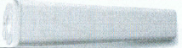
MEGADYNE™ E-Z Pen Reusable Electrosurgical Pencil | E-Z Pen Reusable Electrosurgical Pencil, Rocker switch pencil with holster and cord | 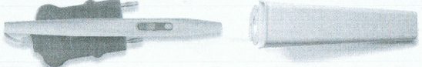
MEGADYNE™ E-Z Pen Reusable Electrosurgical Pencil | E-Z Pen Reusable Electrosurgical Pencil, Button switch pencil with holster and cord | 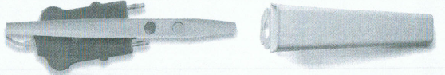
MEGADYNE™ Suction Coagulators | Foot control Suction Coagulators | 
MEGADYNE™ Suction Coagulators | Hand control Suction Coagulators | 
Non-stick electrodes | Blade non-stick electrode
Non-stick electrodes | Needle non-stick electrode
Non-stick electrodes | Blunt Needle non-stick electrode
Non-stick electrodes | Ball non-stick electrode
Non-stick electrodes | Bayonet Needle non-stick electrode | 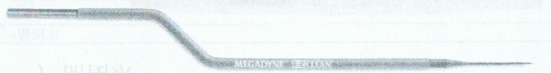
Non-stick electrodes | Fine Needle non-stick electrode
Non-stick electrodes | Angled 45 Degree Fine Needle non-stick electrode | 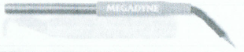
Non-stick electrodes | Angled 90 Degree Fine Needle non-stick electrode | 
Non-stick electrodes | ACE Blade non-stick electrode
Modified Non-stick Electrodes | Blade Non-stick Electrode, Modified
Modified Non-stick Electrodes | Blunt Needle Non-stick Electrode, Modified
Modified Non-stick Electrodes | Needle Non-stick Electrode, Modified
Modified Non-stick Electrodes | Bayonet Needle Non-stick Electrode, Modified | 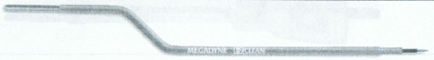
Modified Non-stick Electrodes | Bayonet Blade Non-stick Electrode, Modified | 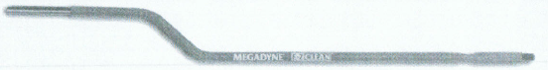
Modified Non-stick Electrodes | Nose Cone Blade Electrode Modified, non-stick | 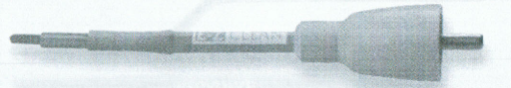
Modified Non-stick Electrodes | Nose Cone Needle Electrode Modified, non-stick | 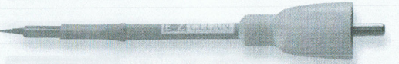
Modified Non-stick Electrodes | ACE Blade non-stick electrode, Modified
MEGADYNE™ Megatip Electrodes | L-Hook MEGADYNE™ Megatip Electrodes | 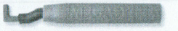
MEGADYNE™ Megatip Electrodes | L-Hook Modified MEGADYNE™ Megatip Electrodes | 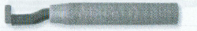
MEGADYNE™ Megatip Electrodes | L-Wire MEGADYNE™ Megatip Electrodes | 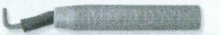
MEGADYNE™ Megatip Electrodes | L-Wire Modified MEGADYNE™ Megatip Electrodes | 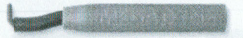
MEGADYNE™ Megatip Electrodes | J-Hook MEGADYNE™ Megatip Electrodes | 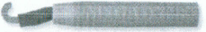
MEGADYNE™ Megatip Electrodes | J-Hook Modified MEGADYNE™ Megatip Electrodes | 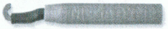
MEGADYNE™ Megatip Electrodes | J-Wire Modified MEGADYNE™ Megatip Electrodes | 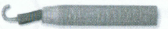
MEGADYNE™ Megatip Electrodes | Spatula MEGADYNE™ Megatip Electrodes | 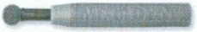
MEGADYNE™ Megatip Electrodes | Curved Blade MEGADYNE™ Megatip Electrodes | 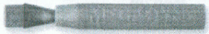
MEGADYNE™ Megatip Electrodes | MEGADYNE™ Reusable Indicator Shaft
MEGADYNE™ Megatip Electrodes | MEGADYNE™ Reusable Indicator Shaft, with Split Stem
LLETZ Loop Electrodes | Non-coated Ball electrode
LLETZ Loop Electrodes | Square Electrode (Orange) | 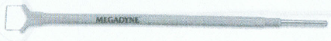
LLETZ Loop Electrodes | Loop Electrode (Purple)
LLETZ Loop Electrodes | Loop Electrode (Gray) | 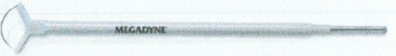
LLETZ Loop Electrodes | Loop Electrode (Red) | 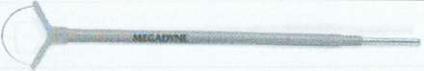
LLETZ Loop Electrodes | Loop Electrode (Yellow)
LLETZ Loop Electrodes | Loop Electrode (Green) | 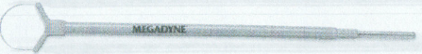
LLETZ Loop Electrodes | Loop Electrode (White) | 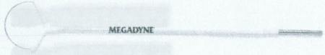
LLETZ Loop Electrodes | Loop Electrode (Blue) | 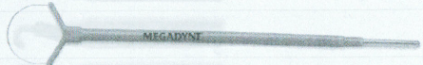
LLETZ Loop Electrodes | Loop Electrode (Tan) | 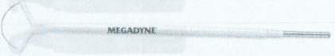
MEGADYNE™ Stainless Steel Blade Electrodes | Stainless Steel Blade Electrode
MEGADYNE™ Stainless Steel Blade Electrodes | Stainless Steel Blade Electrode, Modified
MEGADYNE™ Stainless Steel Blade Electrodes | Stainless Steel Needle Electrode
MEGADYNE™ Stainless Steel Blade Electrodes | Stainless Steel Needle Electrode, Modified
MEGADYNE™ Stainless Steel Blade Electrodes | Stainless Steel Ball Electrode

